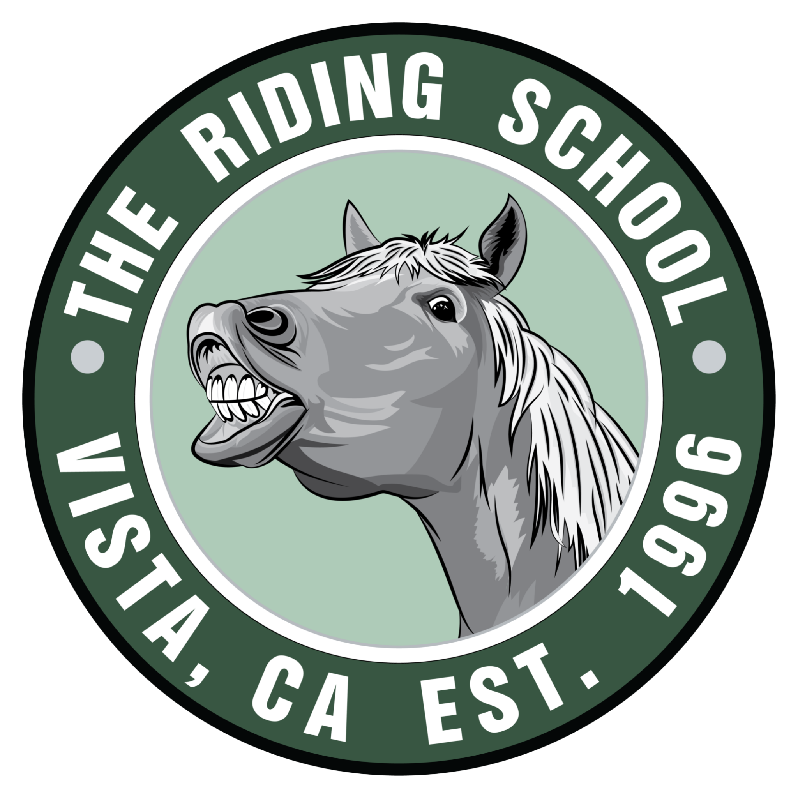
SUMMER HORSEMANSHIP CAMP REGISTRATION 2022
$400 PER CHILD/PER SESSION
$100 FOR SINGLE DAYS

RESERVE YOUR HORSEMAN’S SPOT - SPACES EXTREMELY LIMITED FOR SOCIAL DISTANCING
DATE OF REGISTRATION:
PARENT(S) NAME:
DRIVER’S LICENSE NUMBER FOR CHECK PAYMENTS:
NAME & BIRTHDATE OF HORSEMAN/HORSEMEN):
Name: | Birthdate | Name: | Birthday:
Name: | Birthdate: | Name: | Birthday:

CHECK YOUR DESIRED SESSIONS:
- SESSION 1 June 13-17 | - SESSION 2 June 20-24 | - SESSION 3 June 27- July 1 | - SESSION 4 July 5-8
- SESSION 5 July 11-15 | - SESSION 6 July 18-22 | - SESSION 7 July 25-29 | - SESSION 8 August 1-5 | - SESSION 9 August 8-12
FOR SINGLE DATES, WRITE DOWN WHICH DAY(S)

PHONE NUMBER(S):
EMAIL ADDRESS:
MAILING ADDRESS:
EMERGENCY CONTACT (NAME/NUMBER)
ANY KNOWN ALLERGIES:
CHECK WRITING INSTRUCTIONS:
- Write your check number on this form; be sure to include driver’s license number
- Name of the student(s)
- Note the date(s) of camp you are paying for

PAYMENT INFORMATION:
- 50% Non-Refundable Deposit $200 HOLDS a spot for EACH session (Example: 3 Sessions for one Horseman = $300 Deposit)
- Zelle (Use number 619-701-3444) Cash or Check Accepted
- REMAINING PAYMENT DUE ON OR BEFORE FIRST DAY - REMAINING PAYMENTS ARE NON-REFUNDABLE ONCE CAMPS START
- MAKE CHECKS OUT TO: THE RIDING SCHOOL
- MAIL DEPOSITS TO: PO BOX 2242 Rancho Santa Fe, California 92067 (Call to confirm registration)
- Terms are subject to change without notice. All parents must sign liability waivers for minor children.
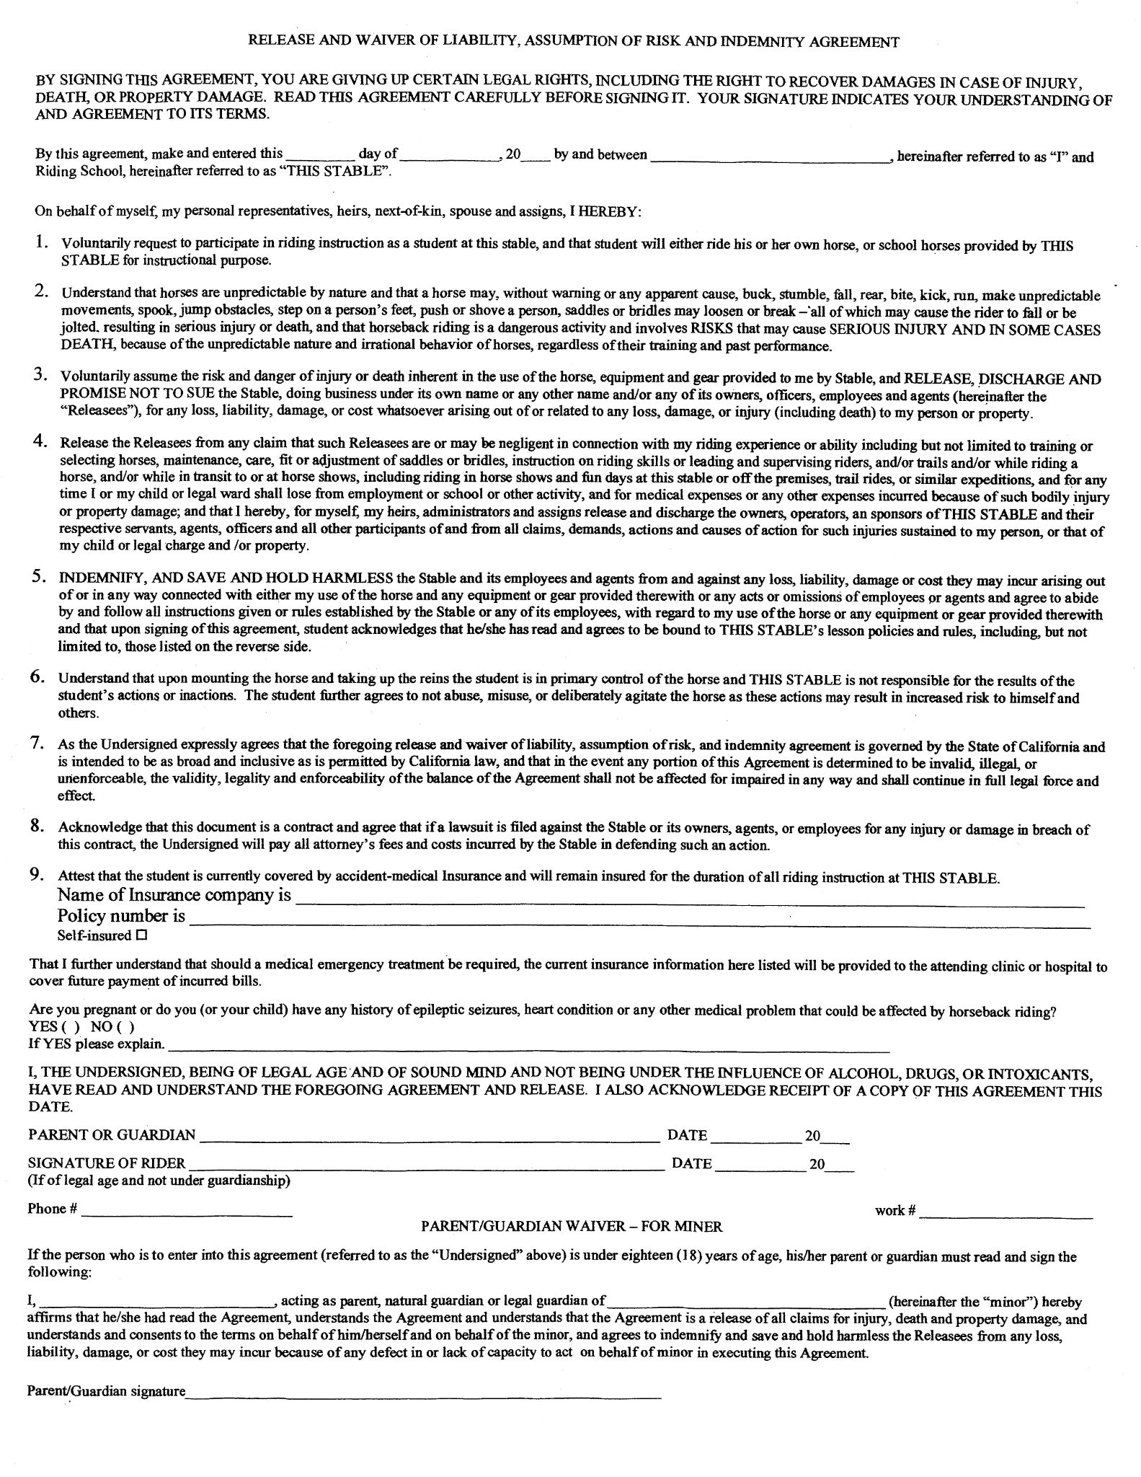
ADMINISTRATIVE NOTES:

DATE DEPOSIT MADE: ______/_______/________
TYPE OF DEPOSIT: CASH / CHECK

